ASSIGNMENT-10.3
HT NO:2303A51961
Batch No:28
Problem Statement 1: AI-Assisted Bug Detection
Scenario: A junior developer wrote the following Python function to calculate factorials:
def factorial(n):
result = 1
for i in range(1, n):
result = result * i return result Instructions:
- Run the code and test it with factorial(5).
- Use an AI assistant to:
  - Identify the logical bug in the code.
  - Explain why the bug occurs (e.g., off-by-one error).
  - Provide a corrected version.
- Compare the AI’s corrected code with your own manual fix.
- Write a brief comparison: Did AI miss any edge cases (e.g., negative numbers, zero)?

Python Code:
- Original Code and Output
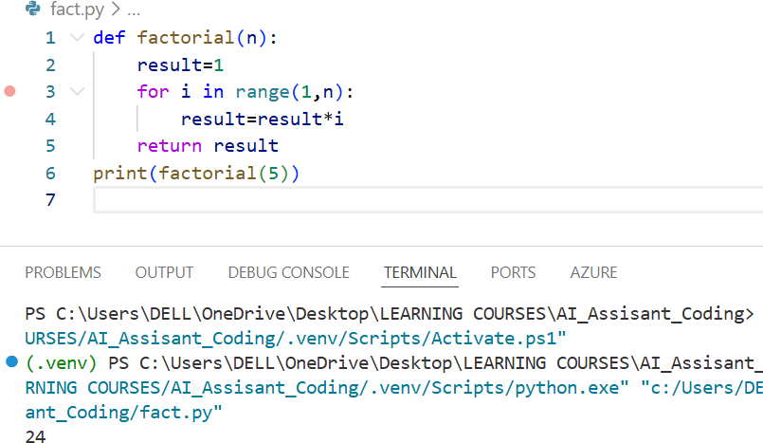
- AI Reviewed Code:
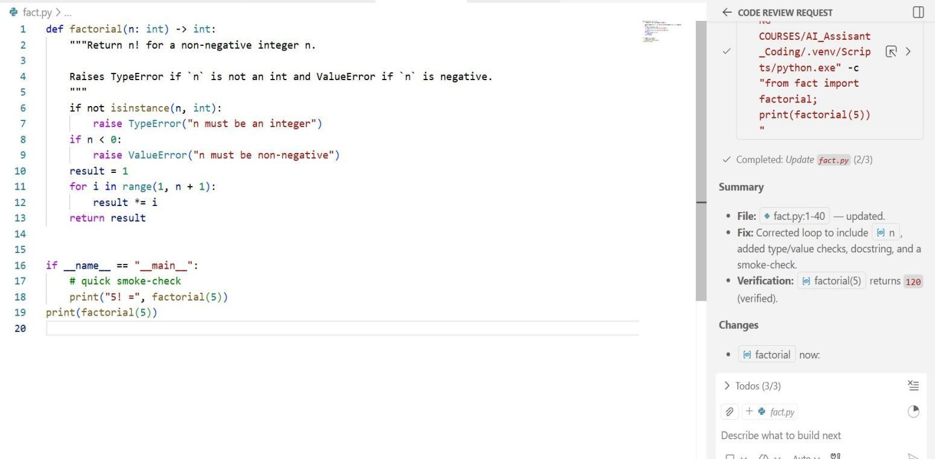

Output:
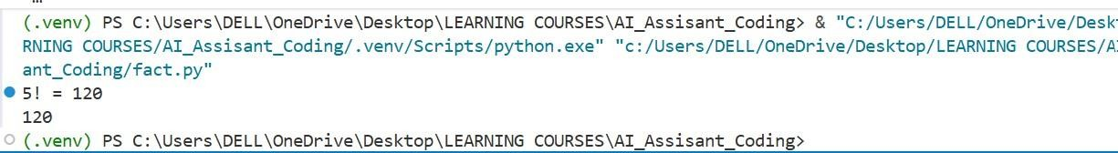
Justification:
- The original function contains an off-by-one error because range(1, n) excludes n, leading to incorrect factorial results.
- AI helps quickly identify logical flaws without manual debugging cycles.
- The corrected version ensures accurate computation for standard inputs like factorial(5) = 120.
- AI may not always handle edge cases (negative numbers, non-integers) unless explicitly prompted.
- Combining manual review with AI improves correctness and robustness. Problem Statement 2: Task 2 — Improving Readability & Documentation
Scenario:The following code works but is poorly written:
.
def calc(a, b, c): if c == "add": return a + b
elif c == "sub": return a - b elif c == "mul":

return a * b elif c == "div":
Instructions:
- Use AI to:
  - Critique the function’s readability, parameter naming, and lack of documentation.
  - Rewrite the function with:
- Descriptive function and parameter names.
- A complete docstring (description, parameters, return value, examples).
- Exception handling for division by zero.
- Consideration of input validation.
- Compare the original and AI-improved versions.
- Test both with valid and invalid inputs (e.g., division by zero, non-string operation).
Python Code:
- Original Code:

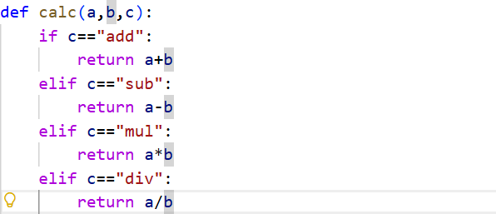

- AI Reviewed Code:
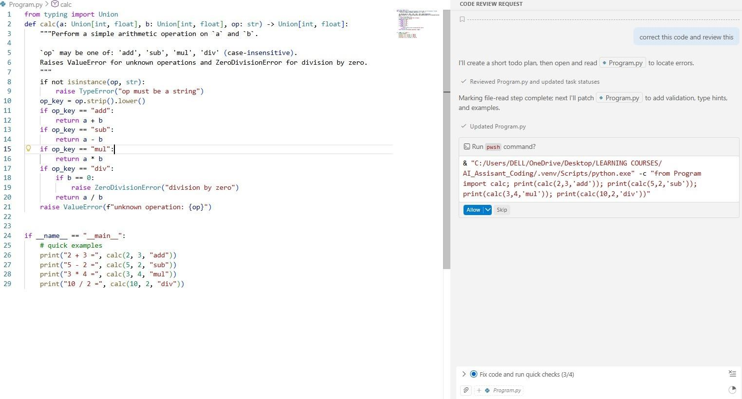

Output:
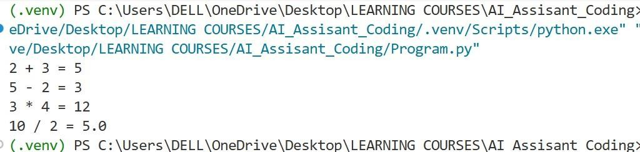
Justification:
- The original function lacks meaningful naming, reducing code clarity.
- Absence of a docstring makes the function harder to understand and reuse.
- No exception handling (e.g., division by zero) makes it unsafe.
- AI refactoring improves maintainability through documentation and validation.
- Structured improvements align the function with professional coding standards.
Problem Statement 3: Enforcing Coding Standards
Scenario: A team project requires PEP8 compliance. A developer submits:
def Checkprime(n):
for i in range(2, n):
if n % i == 0:
return False return True Instructions:
- Verify the function works correctly for sample inputs.
- Use an AI tool (e.g., ChatGPT, GitHub Copilot, or a PEP8 linter

with AI explanation) to:
  - List all PEP8 violations.
  - Refactor the code (function name, spacing, indentation, naming).
- Apply the AI-suggested changes and verify functionality is preserved.
- Write a short note on how automated AI reviews could streamline code reviews in large teams.
Python Code:
- Original Code:
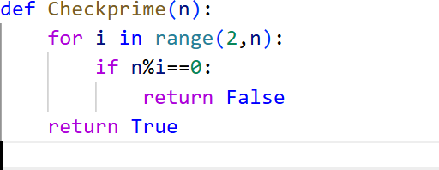

AI Reviewed Code:

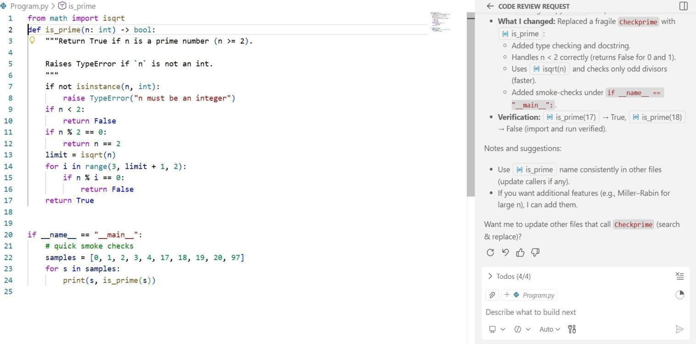
Output:
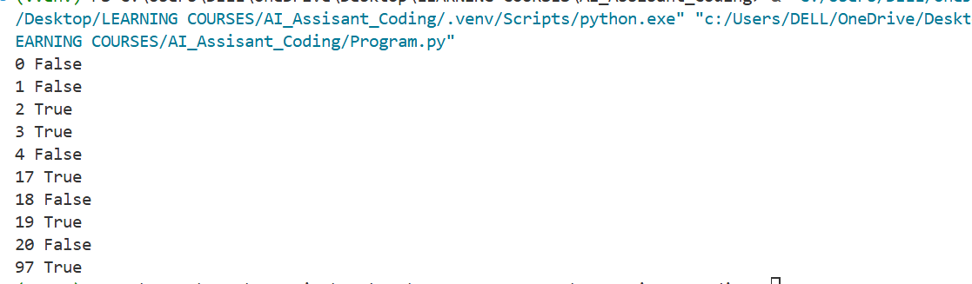
Justification:
- The function violates PEP8 naming conventions (e.g., Checkprime instead of check_prime).
- Proper spacing and formatting improve readability and team collaboration.
- AI tools can systematically detect style violations faster than manual review.
- Refactoring preserves logic while improving compliance.
- Automated reviews enhance consistency in large development teams.
Problem Statement 4: AI as a Code Reviewer in Real Projects

Scenario:
In a GitHub project, a teammate submits: def processData(d):
return [x * 2 for x in d if x % 2 == 0] Instructions:
- Manually review the function for:
  - Readability and naming.
  - Reusability and modularity.
  - Edge cases (non-list input, empty list, non-integer elements).
- Use AI to generate a code review covering:
- Better naming and function purpose clarity.
- Input validation and type hints.
- Suggestions for generalization (e.g., configurable multiplier).
- Refactor the function based on AI feedback.
- Write a short reflection on whether AI should be a standalone reviewer or an assistant.
Python Code:
- Original Code:

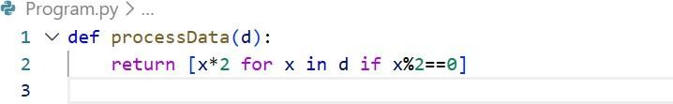

- AI Reviewed Code:
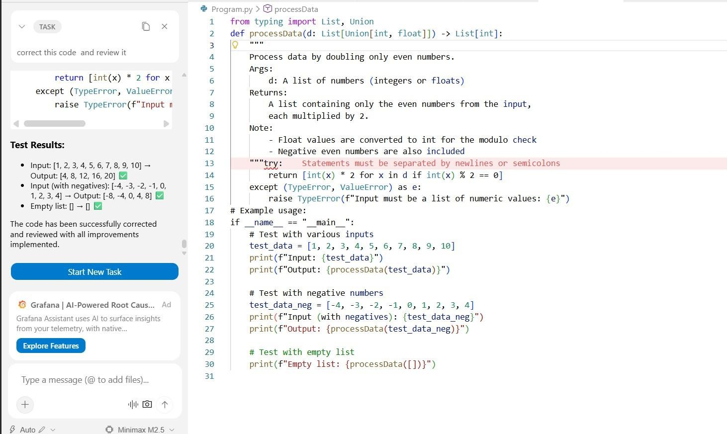
Output:

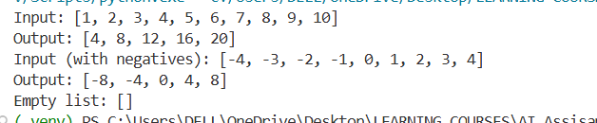
Justification:
- Poor naming (processData, d) reduces function clarity.
- Lack of input validation may cause runtime errors.
- AI suggests type hints, improving static analysis and maintainability.
- Generalizing logic (configurable multiplier) increases reusability.
- AI works best as an assistant reviewer, not a standalone replacement for human judgment.
Problem Statement 5: AI-Assisted Performance Optimization Scenario: You are given a function that processes a list of integers, but it runs slowly on large datasets:
def sum_of_squares(numbers):
total = 0
for num in numbers:
total += num ** 2 return total Instructions:
- Test the function with a large list (e.g., range(1000000)).
- Use AI to:

  - Analyze time complexity.
  - Suggest performance improvements (e.g., using built-in functions, vectorization with NumPy if applicable).
  - Provide an optimized version.
- Compare execution time before and after optimization.
- Discuss trade-offs between readability and performance.
Python Code:
- Original Code:
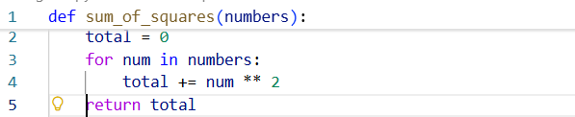

- AI Reviewed Code:
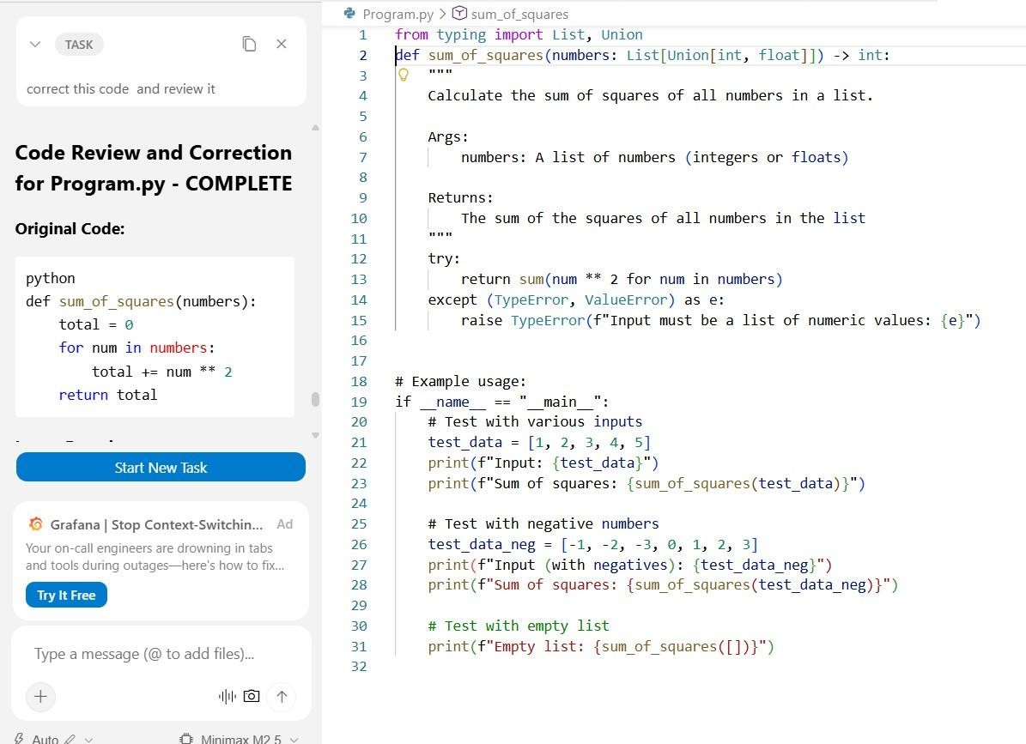
Output:
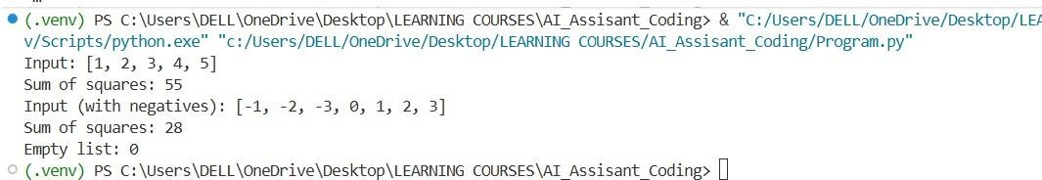

Justification:
- The original loop has O(n) time complexity but can be written more efficiently.
- AI recommends Pythonic constructs (generator expressions with sum()).

- Optimized versions improve performance and memory efficiency.
- Performance testing validates measurable improvements.
- Trade-offs exist between readability, dependency use (e.g., NumPy), and optimization gains.

